**COVENTRY UNIVERSITY**

**Web Applications and AI**

**Student name:**

**Olawale Samuel Badekale**

**Student number:**

**14601655**

**Supervisor name:**

**Manizheh Montazerian**

**INTRODUCTION**

The Trip Agency Management System is a comprehensive web-based application designed to streamline the process of managing and booking trips and tours offered by a travel agency. This system allows both administrators and users to interact efficiently with different features of the platform, making the entire process of trip management and booking seamless and user-friendly.

For administrators, the system provides functionalities like adding, editing, and managing trip details. For end-users, it offers an interactive interface to browse available trips, view trip details, and book trips. Additionally, the system includes a feature for sales prediction based on advertising costs, aimed at helping the agency make informed business decisions using machine learning techniques.

The project employs several software designs patterns, including Model-View-Controller (MVC) to ensure a clean separation between the user interface, business logic, and data access. The use of these design patterns not only simplifies the development and maintenance process but also enhances scalability and modularity, making the system well-structured and easy to extend in the future.

## TECHNOLOGY USED

* Jakarta EE (Java EE)
* SQLite

## APPLICATION DESIGN

The Trip Agency Management System was designed using the Model-View-Controller (MVC) design pattern to ensure scalability, maintainability, and separation of concerns. The Model layer handles data-related operations and business logic, the View layer consists of JSP files that manage the user interface, and the Controller layer, implemented using Servlets, handles HTTP requests and controls application flow. The Data Access Object (DAO) pattern was used to manage database interactions, ensuring that all data access methods are isolated from the core business logic, while the Singleton pattern was employed for efficient database connection management. The frontend was developed using HTML, CSS, Bootstrap, and JavaScript, creating a responsive and user-friendly interface. The system’s database structure is represented by an ER Diagram with key entities such as Users, Trips, and Bookings. The application allows users to register, log in, and book trips, while administrators have additional privileges like adding new trips. Integration with Weka provides machine learning capabilities for revenue prediction based on advertising cost, giving users valuable insights.

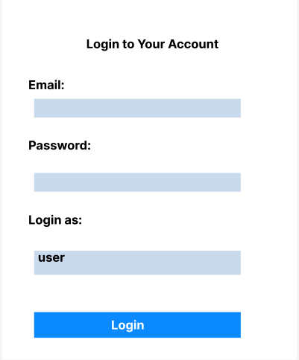

Figure1. Wireframe for the login page

`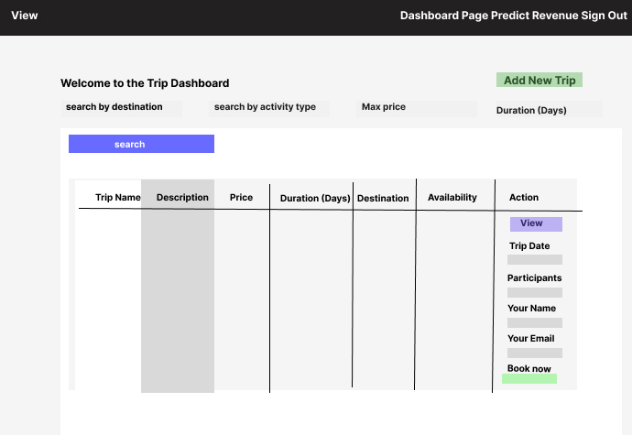

Figure2: wireframe for the Dashboard/user page

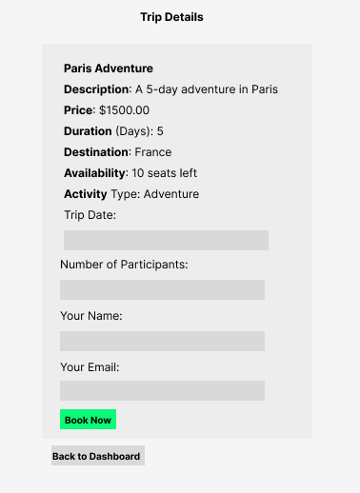

Figure3: wireframe for the Viewdetails page

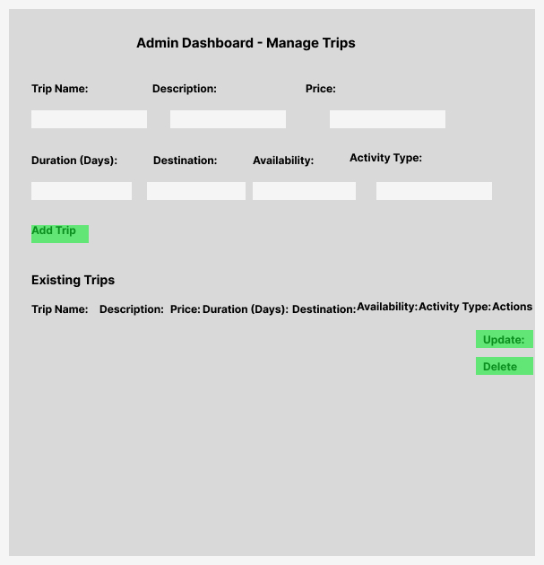

Figure4: wireframe for the admin page

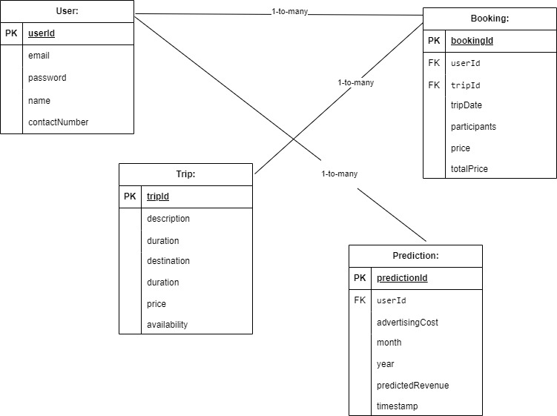

Figure5: (ER DIAGRAM)

## DATABASE

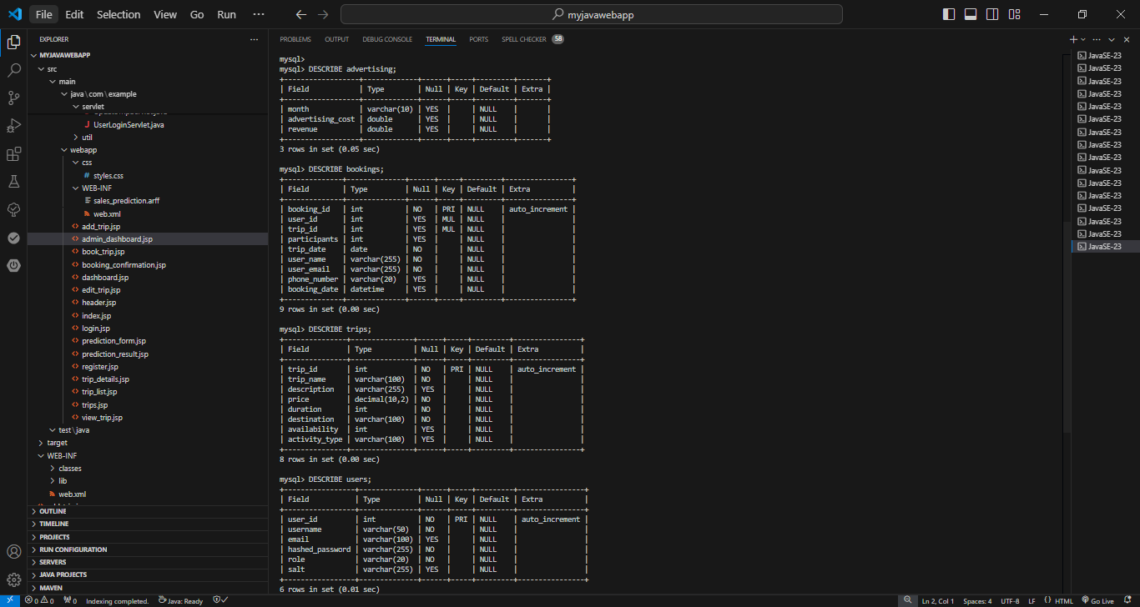

Figure 6(Application Database Table)

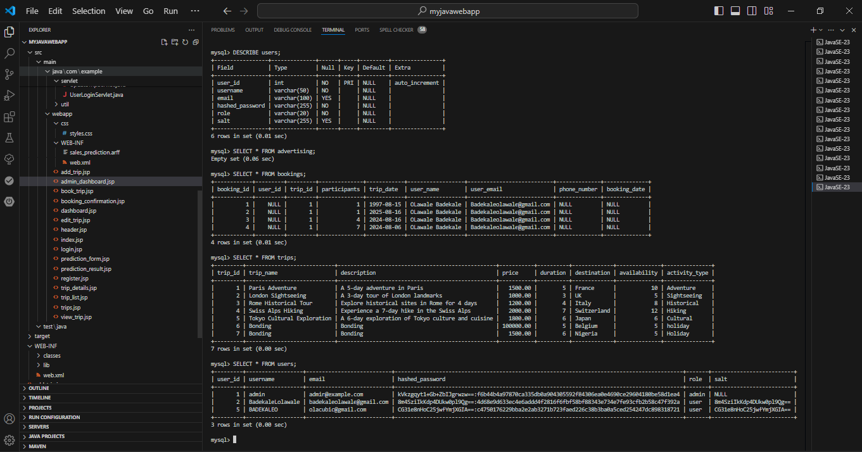

Figure 7(Application Database Table)

## EVIDENCE OF IMPLEMENTATION

## Screenshot and Code of the Application

**The Trip Dashboard page** allows users to explore the various trips offered by the travel agency. It provides a search functionality for filtering trips based on destination, activity type, maximum price, and duration. The dashboard displays a table with trip details, including trip name, description, price, duration, destination, and availability. Users can view detailed information about a specific trip and proceed with booking by entering trip details, such as the trip date, number of participants, name, and email. The header also includes navigation options for accessing the dashboard page, making a revenue prediction, and signing out.

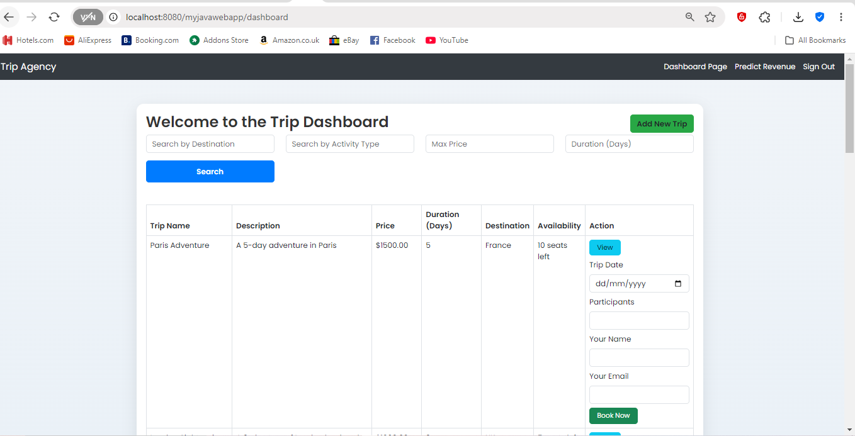

Figure8: Dashboard/user page

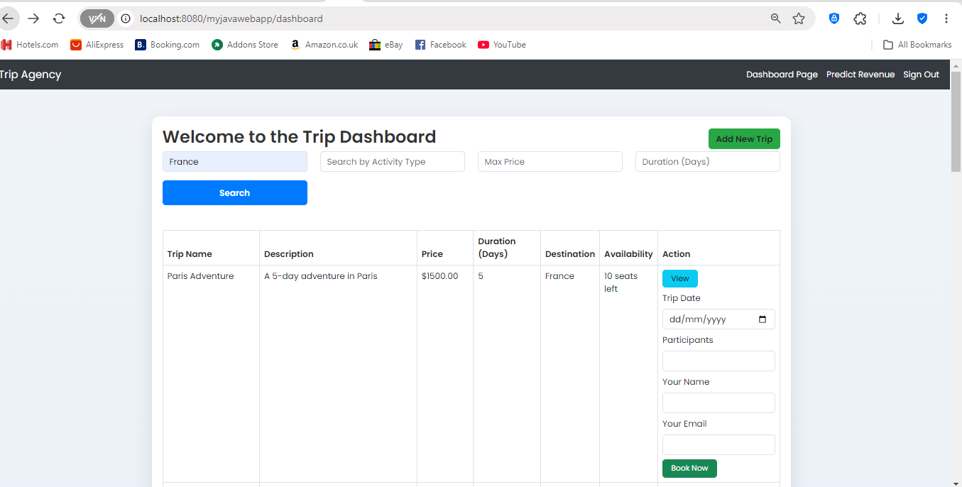

Figure9: Dashboard/user page

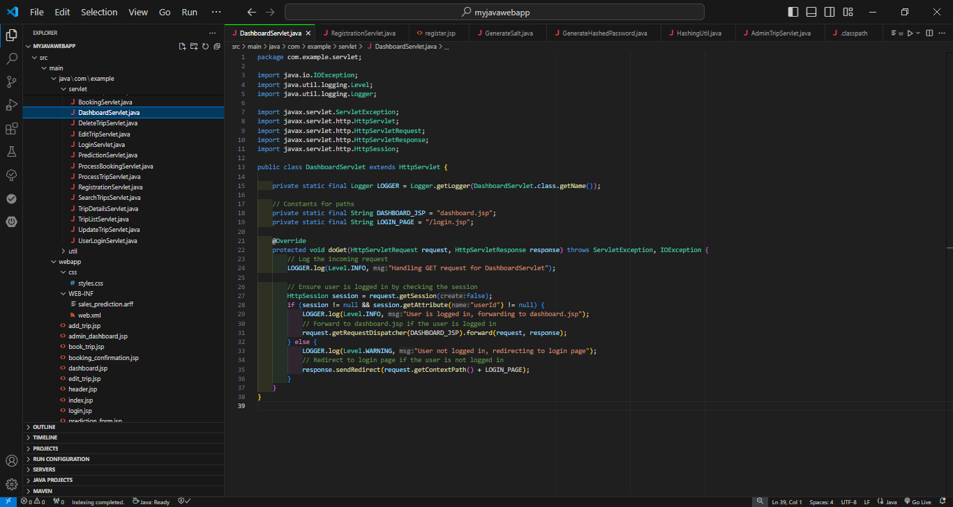

Figure 10(The Servlet code)

**VIEW DETAILED TRIP INFORMATION**

The Trip Details page provides specific information about a selected trip, including the trip's name, description, price, duration, destination, availability, and activity type. It allows users to make a booking by entering relevant details such as the desired trip date, the number of participants, and their personal contact information (name and email). The "Book Now" button at the bottom is used to confirm and process the trip reservation, making this page a key step for users who want to confirm their participation in the chosen trip.

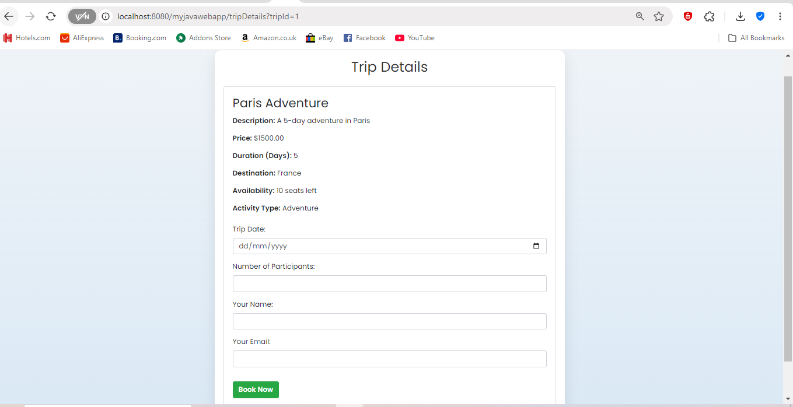

Figure11: Tripdetails page

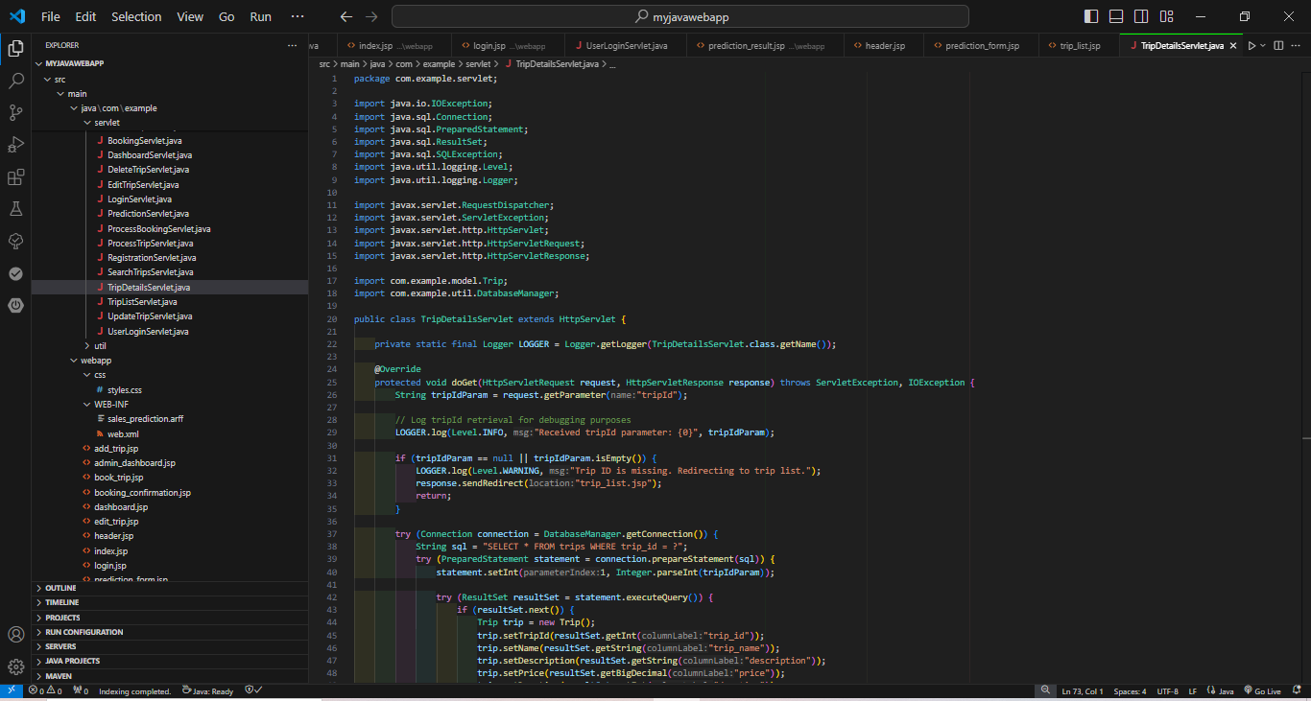

Figure12: Tripdetails Servlet

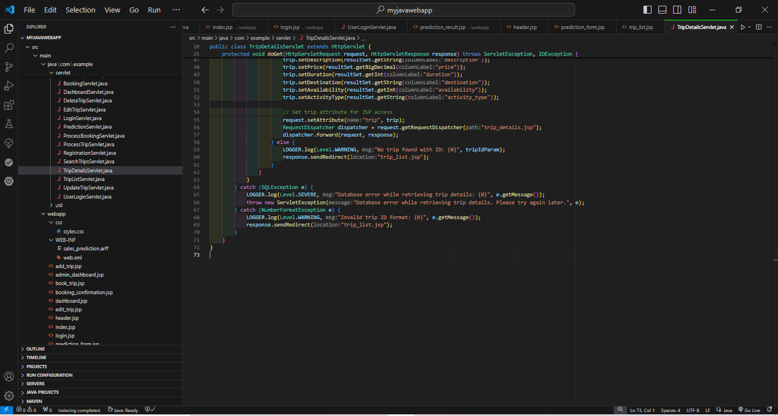

Figure13: Tripdetails Servlet

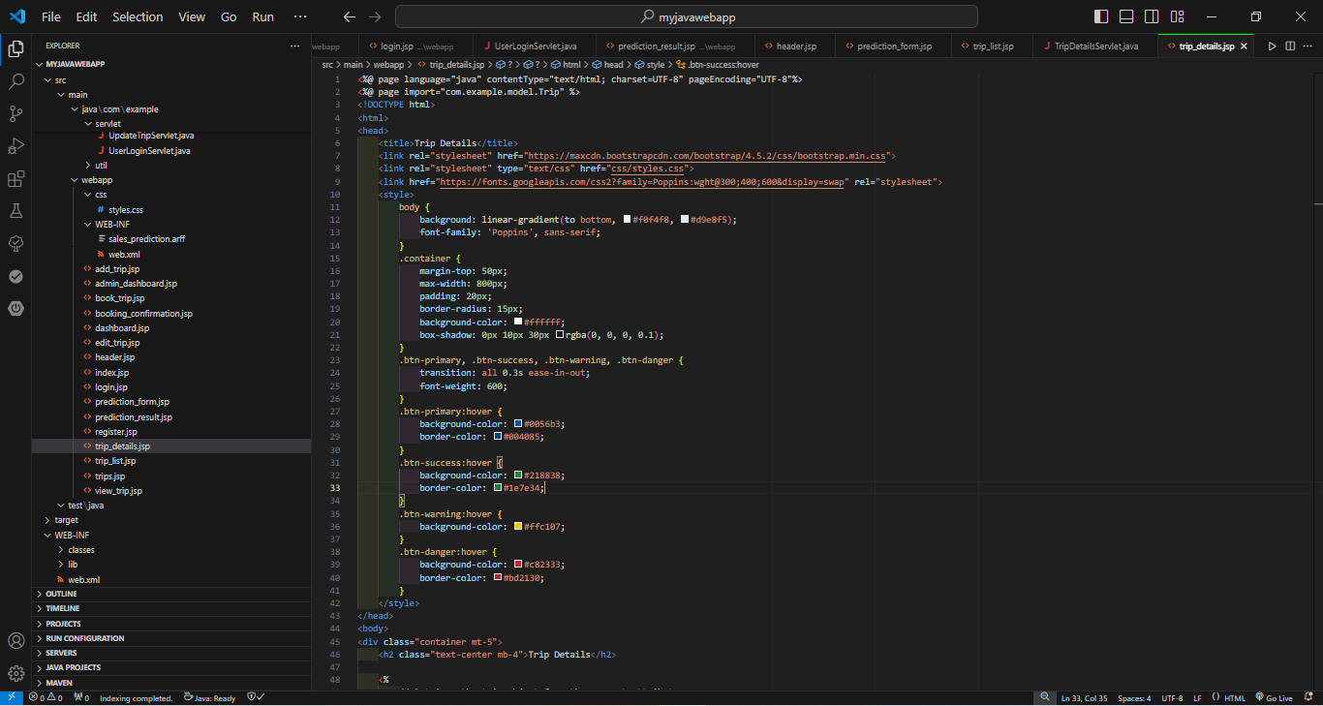

Figure14: Tripdetailsjsp

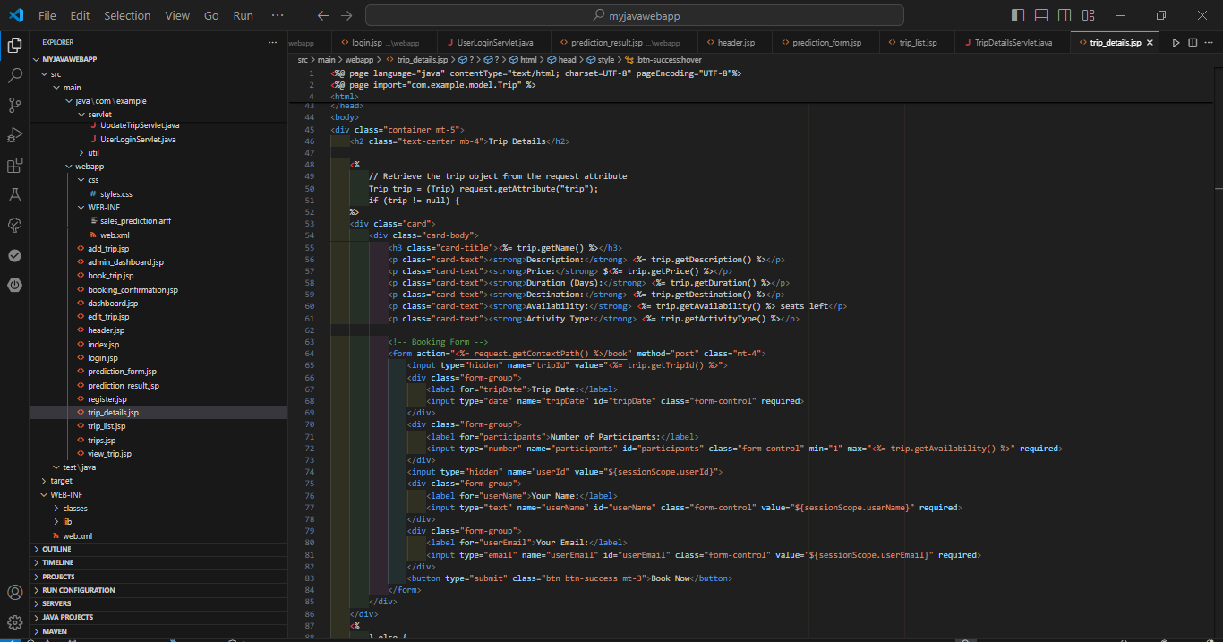

Figure15: Tripdetailsjsp

**ADMIN PAGE TO ADD AND EDIT TRIPS**  
  
The Admin Dashboard for managing trips provides administrators with tools to add new trips or update existing ones. At the top, admins can input trip details such as name, description, price, duration, destination, availability, and activity type to create a new trip by clicking "Add Trip." Below this form, the "Existing Trips" section displays all available trips in a tabular format with editable fields. Admins can make modifications to any trip by clicking the "Update" button or remove a trip from the list using the "Delete" button, offering complete management capabilities for the trips offered by the agency.

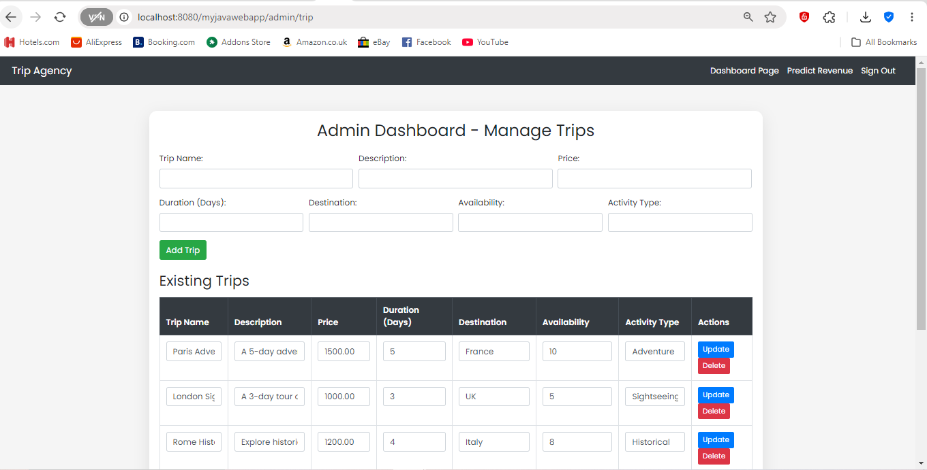

Figure15: Admin page

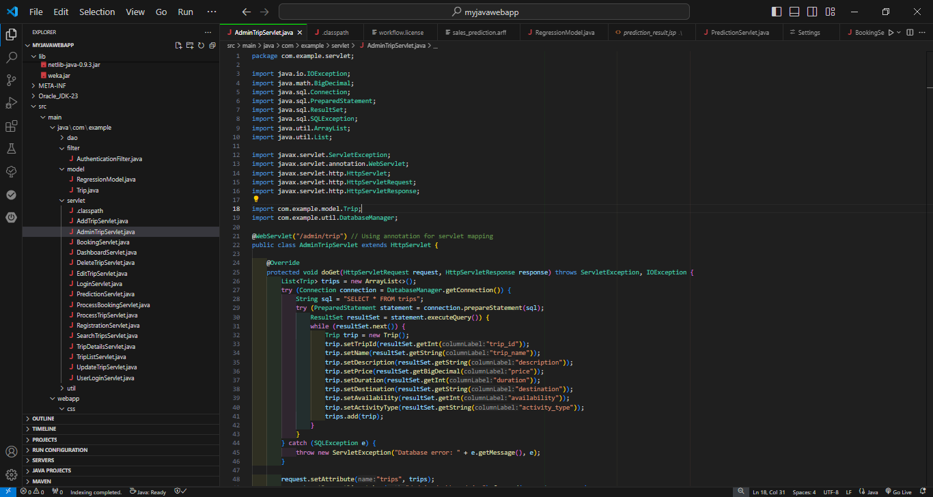

Figure16: AdminTrip servlet

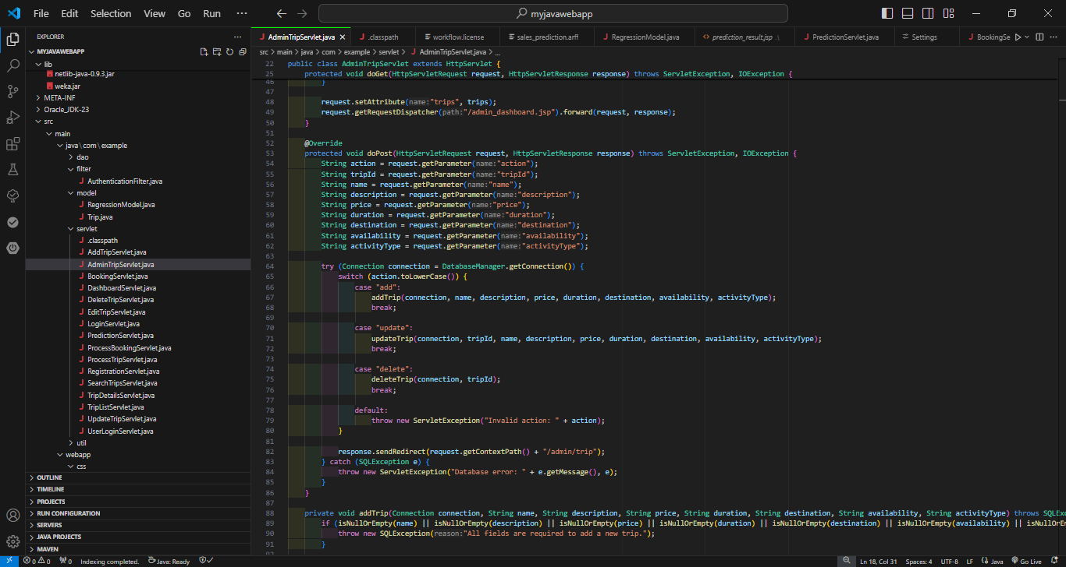

Figure17: AdminTrip servlet

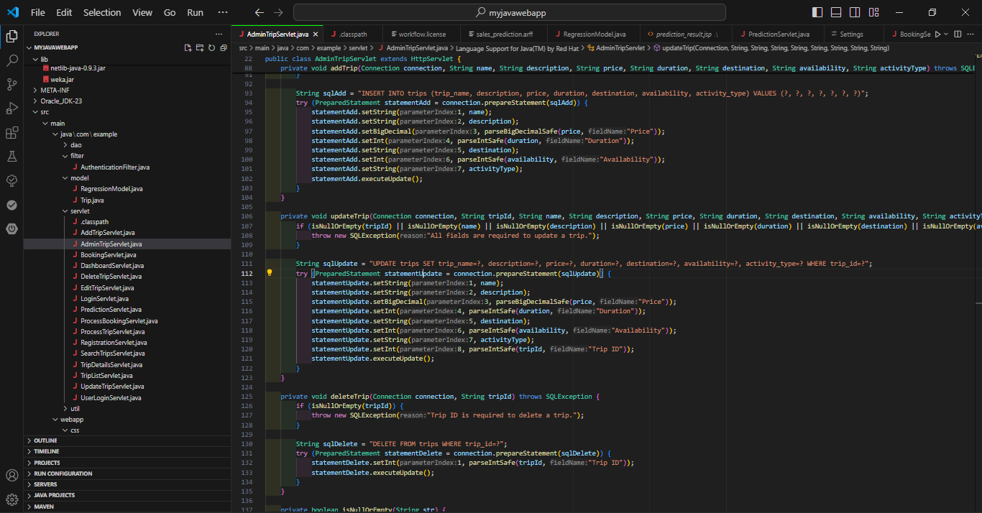

Figure18: AdminTrip servlet

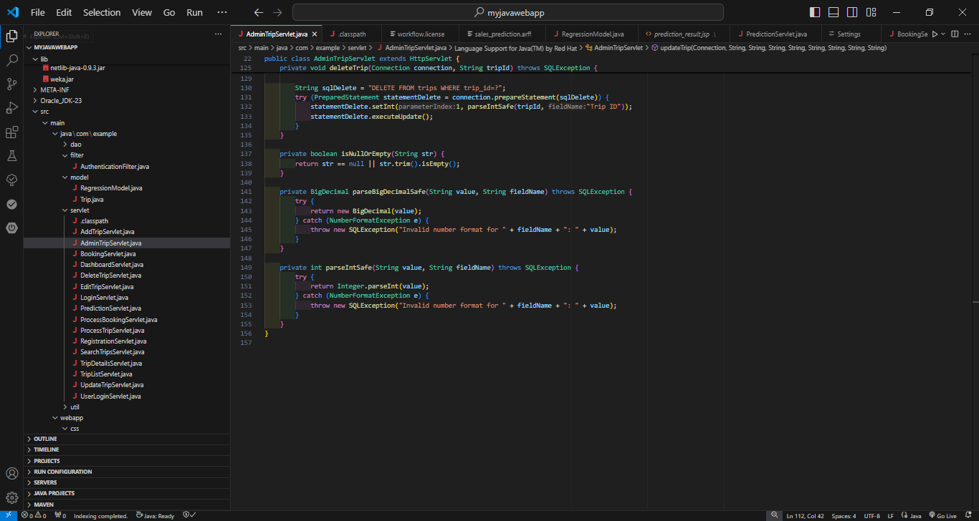

Figure19: AdminTrip servlet

**SALES PREDICTION**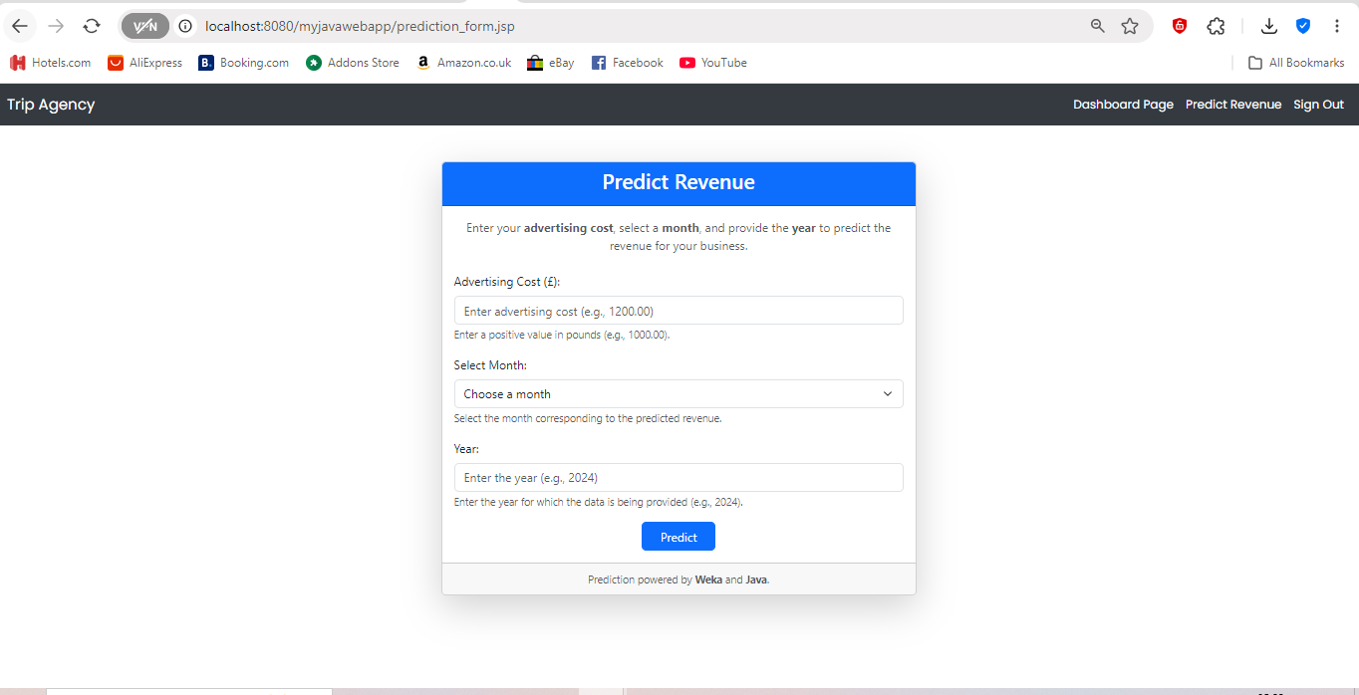

Figure20: prediction form page

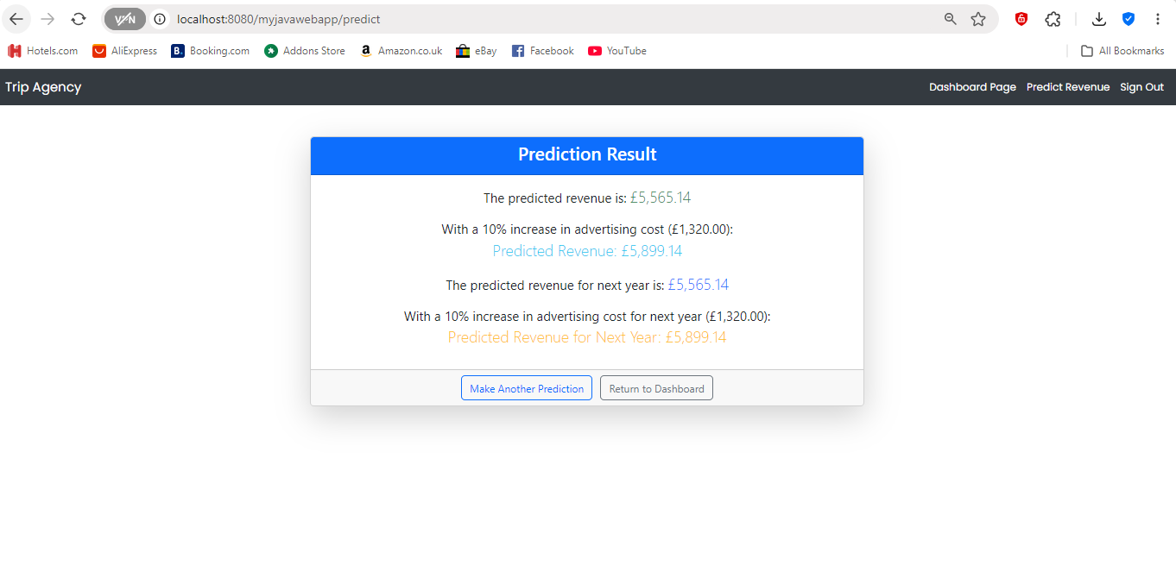

Figure21: prediction result page

The revenue prediction feature in this application uses a machine learning model trained using historical data on advertising costs and their corresponding revenue outcomes. The training process involves a dataset that contains advertising expenses for each month and the revenue generated for that month. The model is built using Weka, which provides a variety of machine learning algorithms and tools. During training, the dataset is split into training and testing sets to evaluate the model’s performance. This predictive model is then used to estimate revenue based on user inputs, such as advertising costs, month, and year, as seen in the form displayed in the user interface. The trained model helps predict future revenue, providing valuable insights for business planning.

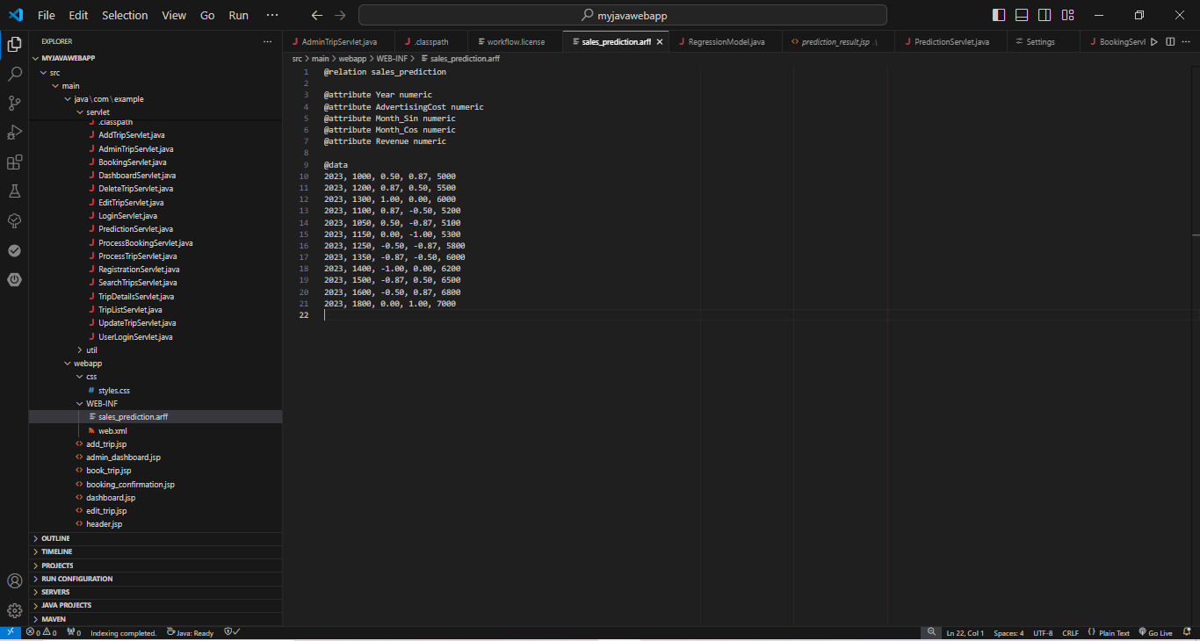

Figure22: Aff file for sales prediction

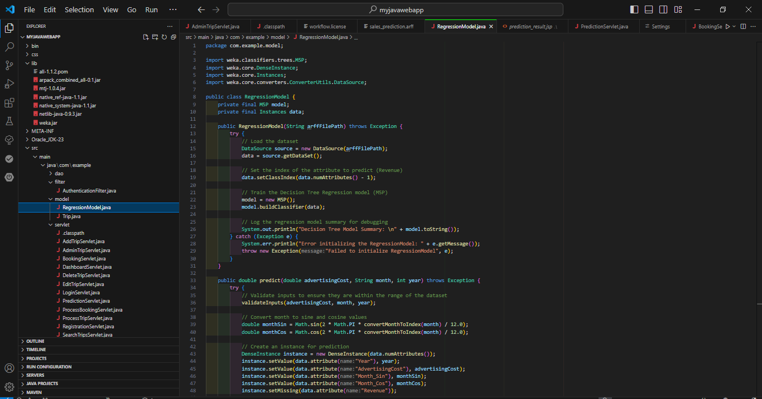

Figure23: Regression model

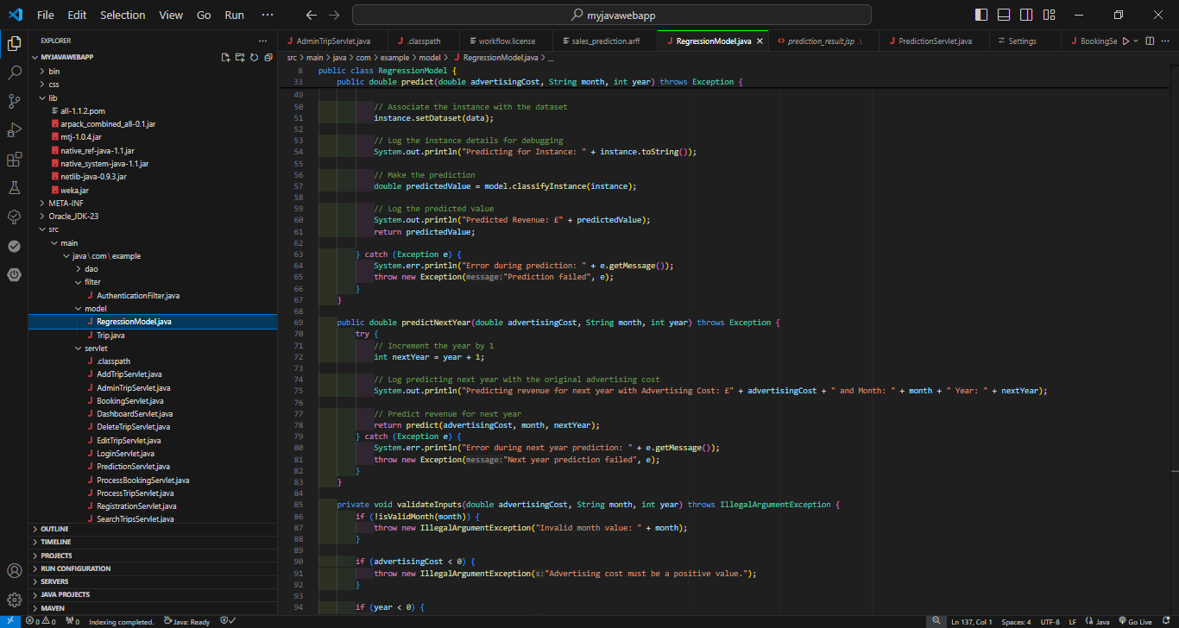

Figure24: Regression model

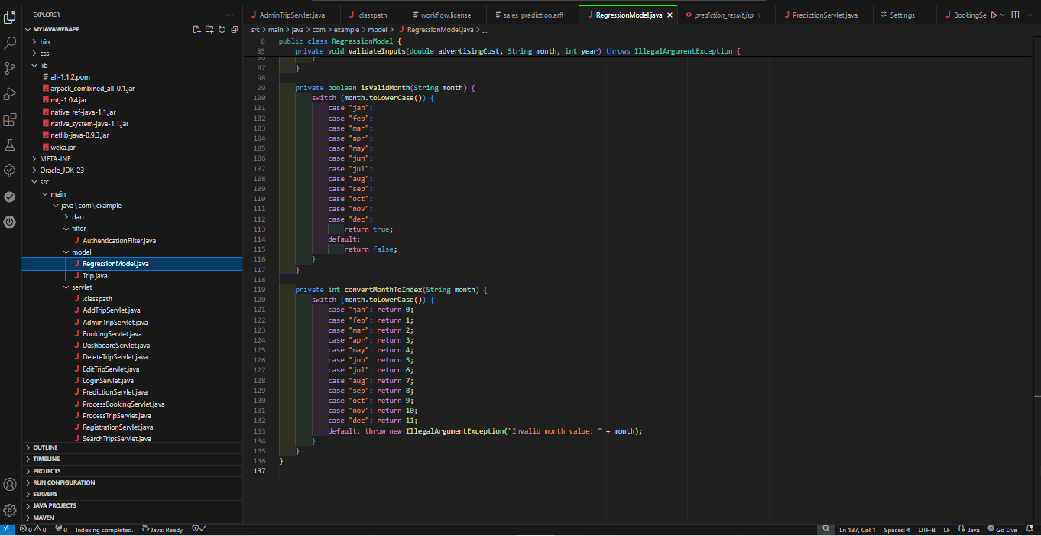

Figure25: Regression model

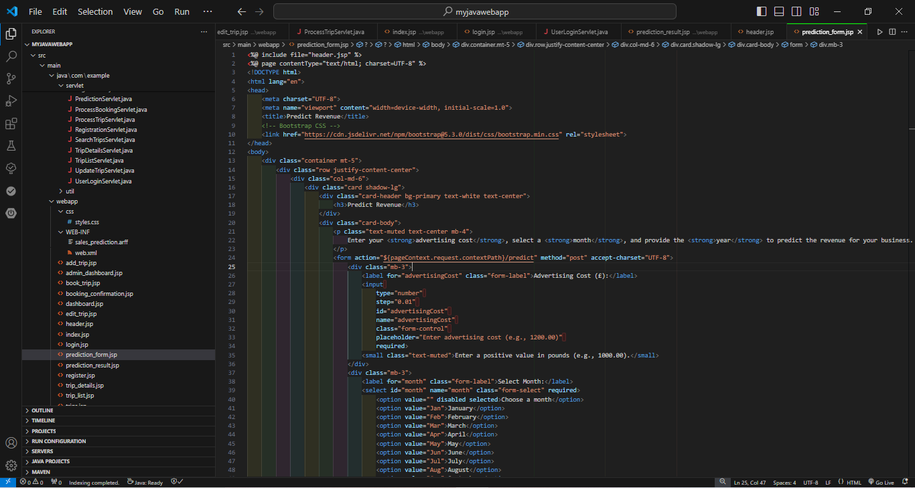

Figure25: prediction_form jsp  
  
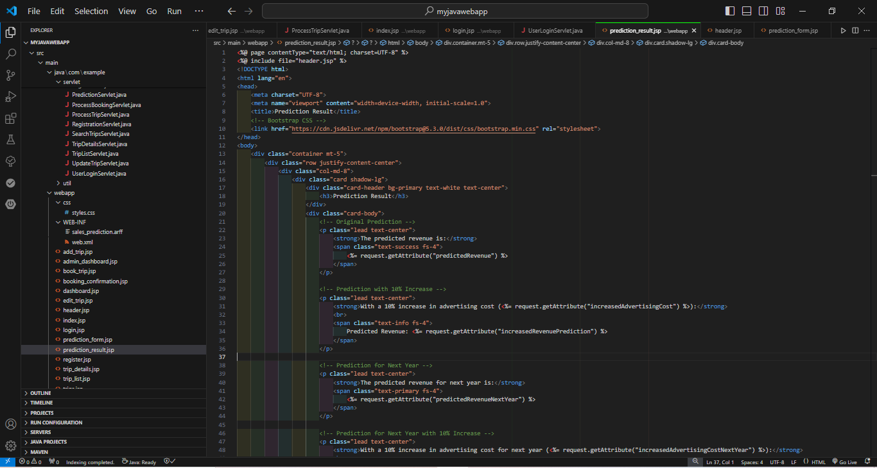

Figure26: prediction_result jsp

Link to video:  
  
<https://livecoventryac-my.sharepoint.com/personal/badekaleo_uni_coventry_ac_uk/_layouts/15/stream.aspx?id=%2Fpersonal%2Fbadekaleo%5Funi%5Fcoventry%5Fac%5Fuk%2FDocuments%2FMyWebAI%20video%2Emp4&nav=eyJyZWZlcnJhbEluZm8iOnsicmVmZXJyYWxBcHAiOiJPbmVEcml2ZUZvckJ1c2luZXNzIiwicmVmZXJyYWxBcHBQbGF0Zm9ybSI6IldlYiIsInJlZmVycmFsTW9kZSI6InZpZXciLCJyZWZlcnJhbFZpZXciOiJNeUZpbGVzTGlua0NvcHkifX0&referrer=StreamWebApp%2EWeb&referrerScenario=AddressBarCopied%2Eview%2E6e5869bc%2D0ab0%2D4d25%2D8d50%2Dcffa9b8e28e6>  
  
  
Link to zip code:   
  
https://livecoventryac-my.sharepoint.com/my?csf=1&web=1&e=bZAcKZ&CID=5bb7fdf7%2D721d%2D4fae%2D8ab0%2D19acd29e713d&id=%2Fpersonal%2Fbadekaleo%5Funi%5Fcoventry%5Fac%5Fuk%2FDocuments%2FMywebAI%20Resit&FolderCTID=0x012000D0D3E82B8BF4514D855C04103D73630F